

UNIVERSITI TEKNOLOGI MALAYSIA

81310, JOHOR BAHRU, JOHOR, MALAYSIA

**SECP1513 (TECHNOLOGY AND INFORMATION SYSTEM)**

**SESSION 2023/2024**

**SECTION 07**

**DESIGN THINKING**

**GROUP 7: INNOVATORS**

**TASK: DESIGN THINKING (REPORT)**

**TITLE: REVOLUTIONISING SMARTWATCH SECURITY**

**(A BREAKTHROUGH IN BIOMETRIC AUTHENTICATION)**

**DATE OF SUBMISSION: 19 JANUARY 2024**

| **NAME** | **MATRIC NUMBER** |
| --- | --- |
| SITI NURUL AMIRAH BINTI SHEIKH SULAIMAN | A23CS0182 |
| NGEOW ZHI YU | A23CS0255 |
| KHOO ZI LING | A23CS0231 |
| NUR FARHANAH HUSNI BINTI NOR FAIZAL | A23CS0155 |
| ERIKA BINTI HAWAPI | A23CS0076 |
| **LECTURER NAME:** TS. DR. SARINA BINTI SULAIMAN | |

**TABLE OF CONTENT**

| **NO** | **CONTENT** | **PAGE** |
| --- | --- | --- |
| 1.0 | Introduction | 3 |
| 2.0 | Design Thinking | 4-5 |
| 3.0 | Detail Description | 6 |
|  | 3.1 Problem | 6 |
|  | 3.2 Solution | 6 |
|  | 3.3 Team Working | 6 |
| 4.0 | Design Thinking Evidence | 7-9 |
|  | 4.1 Empathy | 7 |
|  | 4.2 Define | 7 |
|  | 4.3 Ideate | 8 |
|  | 4.4 Prototype | 9 |
| 5.0 | Video (YouTube Link) | 10 |
| 6.0 | Reflections | 11-13 |
| 7.0 | Appendices | 14-15 |
|  | 7.1 List of Task | 14 |

**1.0 INTRODUCTION**

Our design thinking report will delve into Chapter 7, Privacy, Security, and Ethics. This chapter serves as a comprehensive exploration of the multifaceted implications of technology on individuals, shedding light on privacy threats, security measures, and ethical considerations. As our digital world advances, safeguarding privacy, ensuring security, and upholding ethical standards become increasingly crucial.

The related problems of this chapter are a set of challenges, particularly in authentication methods. Traditional approaches, like PIN codes and patterns, once considered stalwarts in securing sensitive data, are now grappling with inadequacies. These methods heavily rely on easily intercepted or guessed information, leaving accounts vulnerable to unauthorised access. Furthermore, their inability to adapt to evolving threats and provide nuanced control over user access exacerbates the risks. The burden on users to manage multiple passwords for different accounts adds an additional layer of complexity.

**2.0 DESIGN THINKING**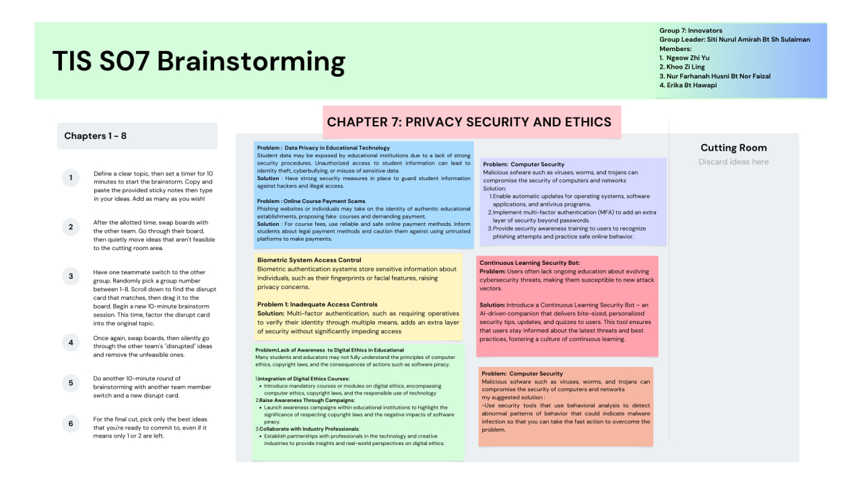

The brainstorming board centres around Chapters 1-8, explicitly emphasising Chapter 7: Privacy, Security, and Ethics, which outlines a six-step process that includes defining topics, swapping ideas, and disrupting the brainstorming process to encourage innovative thinking.

**Problems and Solutions:**

* **Data Privacy in Educational Technology:** Recommends creating secure systems to safeguard student data.
* **Online Course Payment Scams:** Suggests using reliable and secure online payment methods.
* **Biometric System Access Control:** Raises concerns about sensitive information in biometric systems.
* **Inadequate Access Controls:** Proposes implementing multi-factor authentication for enhanced security without significant access impediments.
* **Lack of Awareness of Digital Ethics in Educational Environments:** Recommends campaigns and collaboration with industry professionals to boost awareness.
* **Continuous Learning Security Bot:** Proposes creating a bot to educate users on cybersecurity threats and best practices.

**Cutting Room:** Designated space for discarding unselected ideas.

After a thorough discussion, our group has decided to focus on the Biometric System Access Control idea. Deemed the most suitable solution, it addresses privacy, security, and ethics challenges across chapters 1-8, with a specific emphasis on Chapter 7.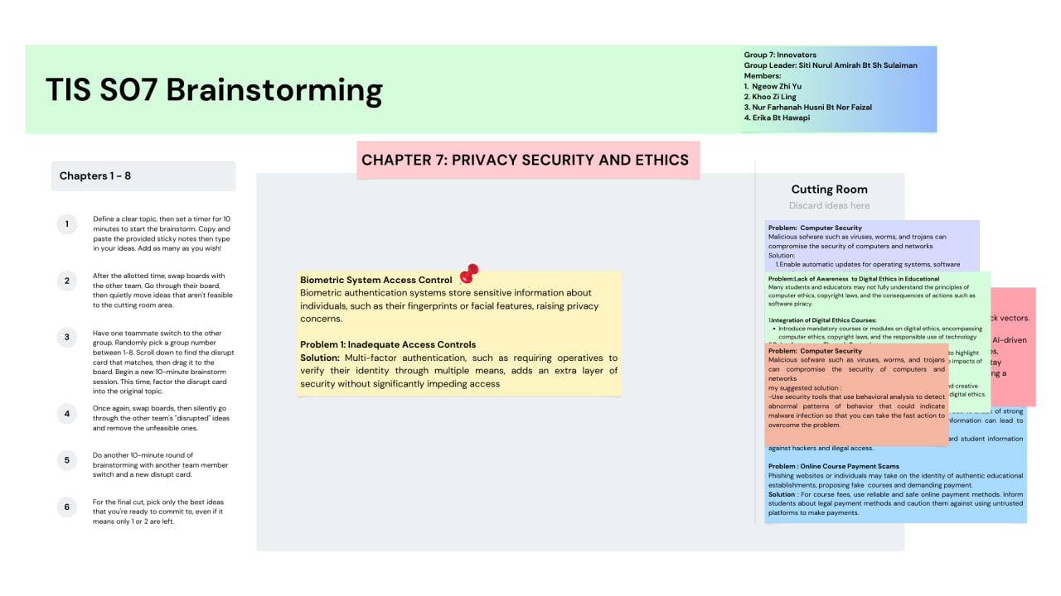

**3.0 DETAILED DESCRIPTION**

**3.1 PROBLEM**

In today's smartwatch landscape, a significant gap exists in secure user authentication, especially needing robust biometric features. Many current smartwatches rely on traditional methods like PIN codes, posing security risks and impacting user experience. This gap highlights the need for advanced biometric authentication to enhance security and convenience.

The lack of biometric authentication compromises data security and hinders seamless interactions with smartwatches. This absence becomes a significant drawback, especially with the growing demand for mobile payments. Users resort to secondary devices like smartphones for secure biometric authentication, limiting the standalone capabilities of smartwatches and obstructing their seamless integration into daily activities.

**3.2 SOLUTION**

On the user experience front, there is a prevalent positive sentiment regarding the convenience of biometric authentication compared to traditional methods like PIN codes. The quick and seamless access to features such as e-Wallets or e-Cards contributes to an overall positive user experience.

To address these challenges and enhance the overall user experience, we propose the development of a cutting-edge smartwatch featuring embedded e-SIM technology and advanced biometric authentication methods, including Face ID and fingerprint recognition. This innovative design not only eliminates the need for a companion smartphone but also ensures secure and frictionless access to sensitive features such as e-Wallet and e-Card transactions.

**3.3 TEAM WORKING**

As of January 18, 2024, our design thinking team fosters innovation through diverse talents and perspectives. Our collaborative approach blends technical expertise, creative thinking, and a user-centric perspective to address complex challenges. Embracing open communication, iterative processes, and understanding consumer needs, we prioritise empathy and experimentation to guide the project toward meaningful outcomes.

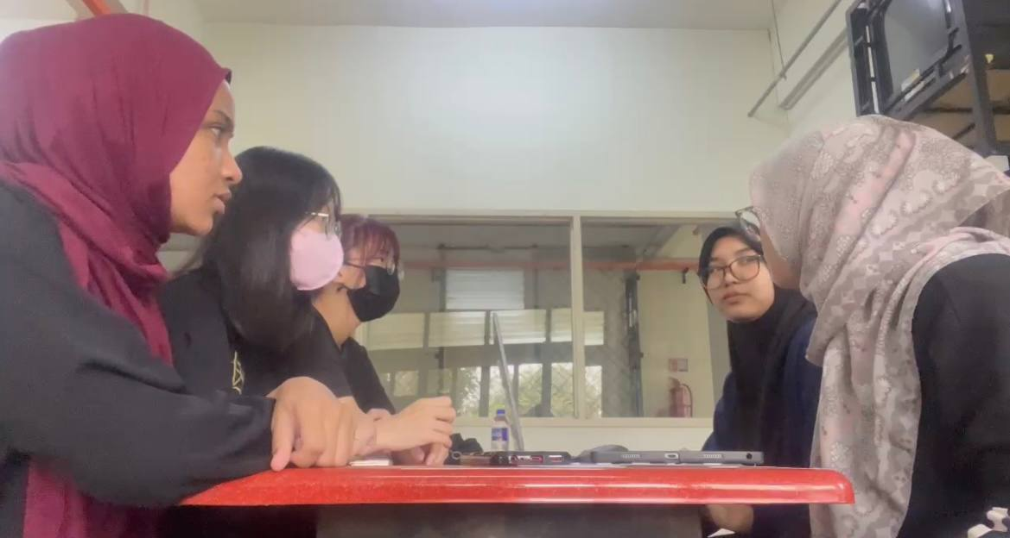

**4.0 DESIGN THINKING EVIDENCE**

**4.1 EMPATHY**

The interview session was crucial to gaining first hand insights into smartwatch users' real-world usage patterns and security perceptions. By directly engaging with users, we unearthed practical scenarios where smartwatches play a role in daily activities and identified security concerns that might not be evident through other means. Alice Lee Hui Mee, a Computer Science student at UTM, showcased the efficiency of using her smartwatch for e-Wallet payments during online shopping and at restaurants.

Cheng Kang Huey, an Electrical Engineering student, highlighted her smartwatch's role in exercise and timers. While expressing confidence in the current security methods, she raised awareness of potential vulnerabilities, particularly if the device is stolen, emphasising concerns related to unauthorised transactions, primarily through Apple Pay. These user perspectives are crucial for understanding both the strengths and areas of improvement in smartwatch functionalities and security measures.

**4.2 DEFINE**

The innovative smartwatch integrates advanced security measures, including a fingerprint scanner for secure access and a face scanner for identity verification during transactions.

1. **Unlocking the Smartwatch with Fingerprint:**
2. Power On
3. Main Screen
4. Fingerprint Sensor
5. Authentication
6. Access Granted

**B) Making Payment with Face Recognition:**

1. Open E-Wallet App
2. Initiate Payment
3. Face Recognition
4. Identity Verification
5. Transaction Confirmation
6. Confirmation Feedback

This smartwatch combines cutting-edge security features with a user-friendly interface and durable design. Its waterproof and lightweight properties, along with the diverse colour options, make it a versatile and stylish accessory for everyday use. The combination of fingerprint and face scanners ensures a high level of security, while the anti-theft measures provide added protection for the user's peace of mind.

**4.3 IDEATE**

Brainstorming and group discussions are collaborative processes to generate and share ideas to solve problems or conceive new concepts. We initiate sessions in comfortable and open spaces to foster a creative environment, encouraging active contribution.

Each team member writes ideas about a specific problem or chapter, expressing unique viewpoints and establishing clear goals for focused and aligned brainstorming. Our team identifies Biometric System Access Control as the focal problem, enabling a targeted exploration of challenges and potential solutions within this domain.

Subsequently, we engage in in-depth discussions, committed to fully understanding every aspect of the selected problem, ensuring comprehensive knowledge before making decisions. Actively discussing solutions, emphasising concept generation and multi-approach thinking, becomes crucial in addressing challenges related to Biometric System Access Control. Encouraging open communication, we approach problem-solving holistically, considering various angles and potential challenges associated with biometric access control.

**4.4 PROTOTYPE**

This prototype integrates cutting-edge security and enhanced connectivity, creating a versatile and user-friendly wearable device. With state-of-the-art features like advanced fingerprint recognition and an e-SIM for standalone connectivity, it redefines the smartwatch experience, offering both security and seamless interaction in the modern era.

|  |
| --- |
|  |

**5.0 VIDEO (YOUTUBE LINK)**

[REVOLUTIONISING SMARTWATCH SECURITY (A BREAKTHROUGH IN BIOMETRIC AUTHENTICATION)](https://youtu.be/G0g_oK4URVg?feature=shared)

**6.0 REFLECTION**

**6.1 SITI NURUL AMIRAH BINTI SHEIKH SULAIMAN**

My goal in pursuing my study in Graphic and Multimedia Software is to unlock my creative potential and explore more about computer science. I would like to delve into the realm of augmented reality and learn how to integrate virtual elements seamlessly with the real world, revolutionising user experience. Furthermore, I aspire to enhance my skills in graphic design and illustration software to create visually stunning and impactful designs that communicate effectively. Throughout my dream study in the Graphic and Multimedia Software course, I aim to gain a deep understanding of various software tools and their capabilities in order to push the boundaries of creativity and innovation in the field of this course.

This design thinking encourages me to approach problem-solving and innovation. In this program, I need to apply these design thinking principles to projects. By brainstorming creative ideas, I aim to develop solutions that not only meet user needs of the project but also create an engaging and delightful user experience.

To enhance my potential in this industry, I need to build a strong network. I think networking and building connections are crucial aspects of achieving success in computer courses. Through proactive interaction with other students and industry professionals, I can expand their knowledge, gain new perspectives and enhance their opportunities. Additionally, participating in industry talk, online forums, and joining a program are excellent ways for me to connect with others. Lastly, I need to understand the significance of this course and always focus on setting goals, overcoming challenges, and achieving success in Graphic and Multimedia Software courses.

**6.2 NGEOW ZHI YU**

My goal for my program in graphics and multimedia are centred around becoming a proficient and innovative professional in the dynamic and creative realms of technology. My goal is to use my education's technical expertise and creative insights to have a positive impact on the rapidly changing field of digital media. Simultaneously, I aim to explore the field of digital media art and animation with the goal of creating engaging visual effects, artwork, and animations for a variety of media, such as games, movies, and commercials.

Design thinking profoundly influences my aspirations within this program. It encourages me to understand the needs and preferences of end-users, fostering a user-centric approach in designing interfaces and interactive elements. Furthermore, I am able to design experiences that are both aesthetically pleasing and functionally efficient by developing empathy for the target audience.

To enhance my potential in the industry, I will aggressively look for chances for professional growth through online courses, workshops, and community interaction to stay up to date on emerging trends and technology because continuous learning is crucial. Besides, collaboration and networking will also be a priority as I look for chances to collaborate with experts and peers in order to broaden my industry connections and acquire a variety of perspectives.

**6.3 KHOO ZI LING**

My ultimate goal as a graphic and multimedia software course student in computer science is to become a proficient and innovative professional in the field of technology. I aspire to contribute to cutting-edge developments in software design and multimedia applications, pushing the boundaries of what is possible within the digital realm. My dream is to be recognized for creating impactful and user-centric solutions that enhance the overall user experience.

This design thinking project not only hones my technical skills but also encourages me to think creatively, considering user needs and industry trends. It also serves as a practical application of my coursework, allowing me to explore real-world challenges and solutions within the realm of graphic and multimedia software. It contributes significantly to my goal of becoming a tech professional who not only understands the theoretical aspects of the field but can also translate that knowledge into tangible, groundbreaking projects.

To enhance my industry potential, I plan to stay updated on graphic and multimedia software trends through continuous learning. Actively engaging in hands-on projects will sharpen my technical skills, while seeking internships and building a professional network will provide practical exposure and collaboration opportunities. Additionally, I recognize the importance of developing soft skills such as communication and teamwork, aiming to become a versatile tech professional capable of translating theoretical knowledge into impactful, real-world solutions.

**6.4 NUR FARHANAH HUSNI BINTI NOR FAIZAL**

My goal in studying graphic and multimedia software is to lay a solid foundation and obtain practical experience for my future job. I want to learn digital tools and build a comprehensive portfolio demonstrating expertise and inventiveness. Ultimately, I want to get a creative position in the industry, such as a graphic designer or multimedia artist.

The design thinking process has had a significant impact on my program objectives. It has allowed me to approach problems with extraordinary inventiveness and a systematic technique, breaking big situations into digestible components while prioritising user requirements. This process has improved my problem-solving abilities and provided helpful tools such as prototyping and user testing, which I can easily apply to future projects. In summary, design thinking has made me a more adept and creative problem solver, aligning with my career goals.

I am dedicated to continuous skill advancement in graphic and multimedia software to bolster my industry standing. This process involves exploring additional courses, seeking mentorship from professionals, and expanding my portfolio. Networking with industry peers and actively pursuing collaborative opportunities on projects are integral parts of my plan. I aim to construct a solid foundation in the field through these actions, ultimately realising my career aspirations.

**6.5 ERIKA BINTI HAWAPI**

My educational goals as a computer science student encompass a multifaceted approach. From technical proficiency and problem-solving skills to ethical awareness and interdisciplinary exposure, my vision is to cultivate a holistic skill set that meets the demands of the ever-evolving field of computer science and contributes positively to society.

The impact of design thinking on my goals and dreams within my computer science program is profound. It shapes my approach to problem-solving, collaboration, and innovation in a manner that not only aligns with my current aspirations but also propels me towards realising my long-term vision of making meaningful contributions to the field of computer science.

To excel in the industry, I prioritise mastering essential programming languages—C++, Python, and Java—widely used in the field. Concurrently, I'm refining problem-solving skills through real-world challenges. Embracing design thinking, I aim for user-centric solutions marked by empathy and innovation. Effective collaboration and communication are focal points honed through group projects and diverse perspectives. Recognizing the industry's dynamic nature, I commit to continuous learning and staying updated on emerging technologies and methodologies. This multifaceted strategy positions me to thrive in the evolving tech landscape.

**7.0 APPENDICES**

**7.1 LIST OF TASK**

Design thinking reports involve team members collaborating, each contributing unique skills and perspectives. This is the distribution list of tasks for each member:

1. **SITI NURUL AMIRAH BINTI SHEIKH SULAIMAN**
2. **Introduction**

* Craft a compelling and informative introduction to set the tone for the design thinking report.
* Provide context for the problem or challenge being addressed.

1. **Report for Design Thinking Evidence: Ideate**

* Showcase how various ideas were explored and evaluated.

1. **KHOO ZI LING**
2. **Editing the Video:**

* Compile and edit video footage of the design thinking process.
* Ensure a cohesive and engaging narrative that visually represents the team's journey.

1. **Uploading the Video to YouTube:**

* Manage the technical aspects of uploading the video to a designated YouTube channel.
* Optimise video settings for accessibility and visibility.

1. **Report for Design Thinking Evidence: Define**

* Outline the problem definition phase, including problem statements and criteria for success.
* Explain how the team arrived at a clear and well-defined problem statement.

1. **NGEOW ZHI YU**
2. **Interview Script**

* Develop a comprehensive script for interviews, ensuring relevant questions are asked.

1. **Interview Session**

* Conduct interviews with relevant stakeholders or users.
* Gather valuable insights and perspectives to inform the design process.

1. **Report for Design Thinking Evidence: Empathy**

* Document the empathetic understanding of users' needs and pain points.
* Highlight critical findings from the interview sessions.

1. **NUR FARHANAH HUSNI BINTI NOR FAIZAL**
2. **Sketching the Prototype:**

* Create hand-drawn sketches or digital illustrations of the proposed design solutions.
* Visualise the initial concepts for further exploration.

1. **Report for Design Thinking Part:**

* Contribute to the overall design thinking report, mainly focusing on the part related to the prototyping phase.
* Explain the rationale behind the chosen design concepts.

1. **ERIKA BINTI HAWAPI**
2. **Detail Description**

* Provide detailed descriptions of key aspects of the design, such as features, functionalities, and user interactions.
* Ensure clarity and precision in conveying design details.

1. **Designing the Prototype using Figma**

* Utilise Figma to create a digital prototype based on the finalised design concepts.
* Ensure that the prototype accurately represents the proposed solution.

1. **Report for Design Thinking Evidence: Prototype**

* Document the prototyping phase, including iterations and improvements made.
* Showcase the final prototype and its alignment with user needs.